Software Requirements Specification
for
Comp2Dust
Version 1.0 approved
Prepared by Yiğit Şık

05/04/2021
Table of Contents

1. Introduction
1.1 Purpose
1.2 Scope
1.3 Definitions, Acronyms, and Abbreviations
1.4 References
1.5 Overview

2. The Overall Description
2.1 Product Perspective
2.1.1 System Interfaces
2.1.2 Interfaces
2.1.3 Hardware Interfaces
2.1.4 Software Interfaces
2.1.5 Communications Interfaces
2.1.6 Memory Constraints
2.1.7 Operations
2.1.8 Site Adaptation Requirements
2.2 Product Functions
2.3 User Characteristics
2.4 Constraints
2.5 Assumptions and Dependencies
2.6 Apportioning of Requirements

3. Specific Requirements
3.1 External interfaces
3.2 Functions
3.3 Performance Requirements
3.4 Logical Database Requirements
3.5 Design Constraints

Change History
Name | Date | Reason | Version
Yiğit Şık | 19/04/2021 | Initial Commit | 1.0.0

1. Introduction

1.1 Purpose

The purpose of this document is to present a detailed description of the “Comp2Dust” image compression site. It will explain the purpose and features of the site, the interfaces of the site, what the site will do and the constraints under which it must operate.

1.2 Scope

This web site is an online image compressor. It is designed to shrink files sizes while maintaining the image quality. JPEG, and Png formats make most of the entire internet’s image traffic. That is why this web site will be aiming these two format. Due to increasing upload numbers each day, it become a need to optimize content.
So our system will provide optimization services for developers, web site owners, people who have large archives and such…

1.3 Definitions, Acronyms, and Abbreviations.

Terms | Definitions
SRS | System Requirements Specification
API | Application Programming Interface
GUI | Graphical User Interface
Route | Transportation path
IEEE | Institute of Electrical and Electronics Engineers
JPEG | Joint Photographic Experts Group
PNG | Portable Graphics Format

1.4 References

IEEE. IEEE Std 830-1998 IEEE Recommended Practice for Software Requirements Specifications. IEEE Computer Society, 1998.

1.5 Overview

The next chapter, the Overall Description section, of this document gives an overview of the functionality of the product. It describes the informal requirements and is used to establish a context for the technical requirements specification in the next chapter.
The third chapter, Requirements Specification section, of this document is written primarily for the developers and describes in technical terms the details of the functionality of the product.

2. The Overall Description

This section will give an overview of the whole system. The system will be explained in its context to show how the system interacts with other systems and introduce the basic functionality of it. At last, the constraints and assumptions for the system will be presented.

2.1 Product Perspective

The system consist two main functions that works on the client side. The user uploads an image that he needs to compress. It can be Png or Jpeg file algorithm will detect which file was uploaded and will run accordingly.The user will choose from options provided and accept it. Then the newly processed file will be shown to screen, while its data displayed. Finally the user can download his optimized file, and the data of the image he decided to download will be saved to database for statistics purposes.
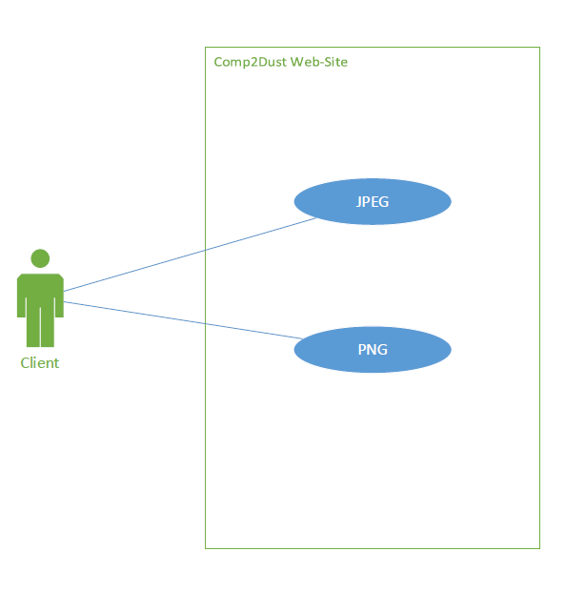

2.1.1 System Interfaces
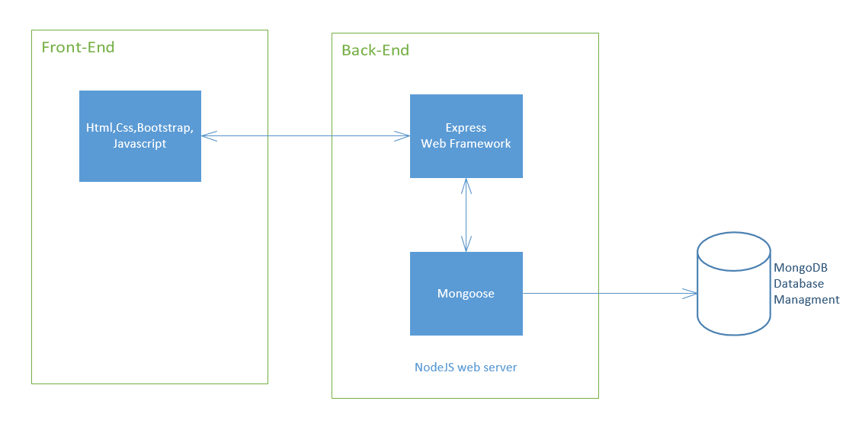

Comp2Dust web site’s compression function operates on client side. This happens through an external npm packages which will be explained in detail in chapter 3.
Site uses express js framework for routing and mongoose to upload image data to MongoDB Atlas Server.

2.1.2 Interfaces



Comp2Dust planned to be a single page application which will consist a button to let user upload an image, options bars to enter desired values and read only textareas to display information about image and image containers to display the images.

2.1.3 Hardware Interfaces

Because Comp2Dust system is web based, it is compatible with all the browsers and can be run on any operating system and processor.

2.1.4 Software Interfaces

MongoDB database with Atlas cloud service to keep image data but not images themselves.

In terms of user interface, HTML, CSS, and Bootstrap library will be used to illustrate the system attractively.

Client side compression function depends on npm package called “compress-js”.

Another npm package to called “body-parser” to get parsed information from HTML to server side.

On the server side, express js will be used to handle routes and mongoose to connect database.

Site will be hosted on Heroku servers.

2.1.5 Communications Interfaces

There is no communication interface yet. But a contact panel or registration system may be included on scaling of product.

2.1.6 Memory Constraints

For the functions provided there is no limitation on uploaded image size. But only one image can be processed once.

2.1.7 Operations

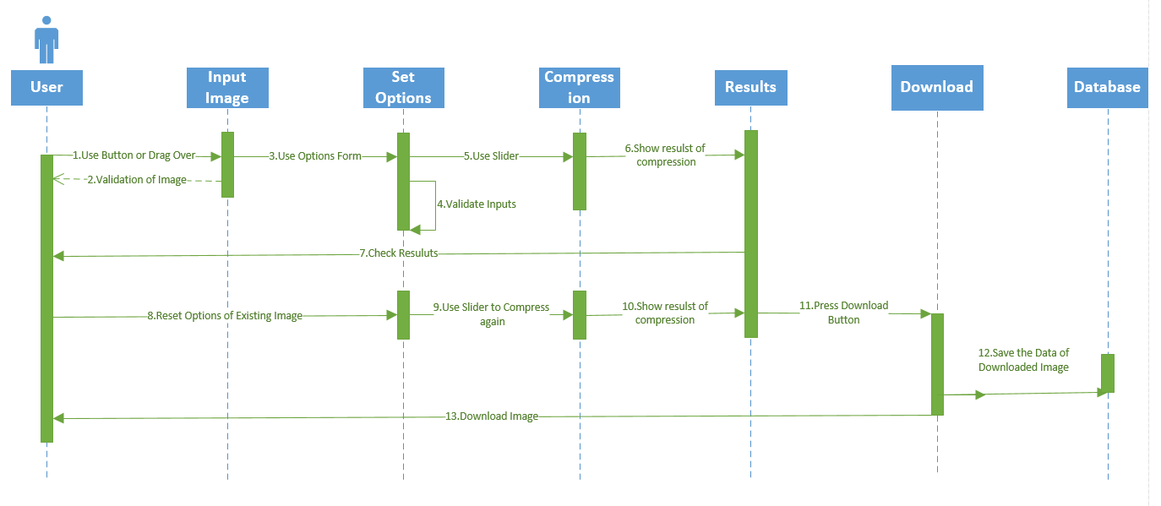

2.1.8 Site Adaptation Requirements

Comp2Dust system is able to perform every platform for example any browser that can be run on any operating system so it does not need any adaptation to a particular platform.

2.2 Product Functions
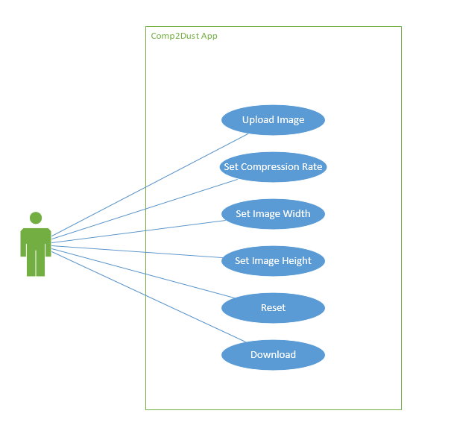
All use cases are explained below:
- Upload Image: Users can upload an image at a time that is desired to be optimized. This can be done either input button or a drag over. The Image format must be .jpg or .png.
- Set Compression Rate: Sets compression value through a slider. It will have immideate effect on image.
- Set Image Width: Sets image’s width dimension with a form element. It will show its effect on compression slider used.
- Set Image Height: Sets image’s height dimension with a form element. It will show its effect on compression slider used.
- Reset: Reset button sets all options to default value and puts back the original image.
- Download: Downloads the compressed image.

2.3 User Characteristics

Comp2Dust web site is an online platform available for every user who has an internet connection and any popular browser such as Firefox,Mozilla,Chrome... Our intended users are people who need smaller sizes for their environment. And since we have covered three main formats that todays internet, we have common users.

2.4 Constraints

- The users can not upload files beside Jpeg and Png formats.
- Giff format can be compressed too but only initial frame and after compression it will no longer animate. For that reasons we did’
- The ouput file type will be only .jpg file.

2.5 Assumptions and Dependencies

User interface and some functionalities can change during the development process of project. And also new functionalities can be added which is able to change the dependent system requirements.

The compression algorithm can be switched to better one. Or can be constructed from scratch on possibility.

2.6 Apportioning of Requirements.

- The scientific algorithm may not be developed to time and resource constraints
- There might be lack of use case on gathered image statistics

3. Specific Requirements

In this section we will explain the specific requirements in three layered architecture.

3.1 External Interfaces

The system shall consist of user friendly web based user interfaces which are explained in 2.2. Product Functions section and whose prototype given in section
2.1.2.

3.2 Functions

Use Case ID | UC1
Actor(s) | User
Description | Upload Image
Preconditions | No precondition
Post conditions | No post condition
Precedence | Mandatory
Normal flow of event | 1. The user opens the browser.  2. User presses input button or  Drags the image to the image card.
Alternative Flow(s) | Flow 1:  1. If user, uploads a file in wrong format a warning message will be shown by the system.  Flow 2:  1. If image sucsessfuly loads user will be ready to set options and compress the iamge.

Use Case ID | UC2
Actor(s) | User
Description | Set Compression Rate
Preconditions | There need to be an image uploaded previously.
Post conditions | No post condition
Precedence | Mandatory
Normal flow of event | - The user uses slider to set compression rate.  - Effect of compression occurs immediately after first step.
Alternative Flow(s) | Flow 1:  1. If user uploads an image that has been fully compressed before, the image will not compressed more.

Use Case ID | UC3
Actor(s) | User
Description | Set Image Width
Preconditions | There need to be an image uploaded previously.
Post conditions | In order to see the effect, user must use compression slider.
Precedence | Optional
Normal flow of event | - The user sets the width through input selector which is placed in options card.  - User uses slider and sees the effect.
Alternative Flow(s) | Flow 1:  1. If user sets width to 0, an alert message will be shown. If user not changes the value and still use slider to compress, the algorithm will use its old with value.

Use Case ID | UC4
Actor(s) | User
Description | Set Image Height
Preconditions | There need to be an image uploaded previously.
Post conditions | In order to see the effect, user must use compression slider.
Precedence | Optional
Normal flow of event | - The user sets the height through input selector which is placed in options card.  - User uses slider and sees the effect.
Alternative Flow(s) | Flow 1:  1 If user sets height to 0, an alert message will be shown. If user not changes the value and still use slider to compress, the algorithm will use its old with value.

Use Case ID | UC5
Actor(s) | User
Description | Reset
Preconditions | There need to be an image uploaded previously.
Post conditions | User will be able to log in to the system
Precedence | Optional
Normal flow of event | - The user clicks to reset button.  - Option values cleared  - The original image loads again.

Use Case ID | UC6
Actor(s) | User
Description | Download
Preconditions | There need to be an image uploaded previously.
Post conditions | No post condition
Precedence | Mandatory
Normal flow of event | - The user satisfied with the results.  - User clicks download button to get his optimized image.  - Data of the Image uploads from server to MongoDB database.

3.3 Performance Requirements

Comp2Dust web application can only compress one image at a time. It takes less than a second.

3.4 Logical Database Requirements

These properties will be saved to database.

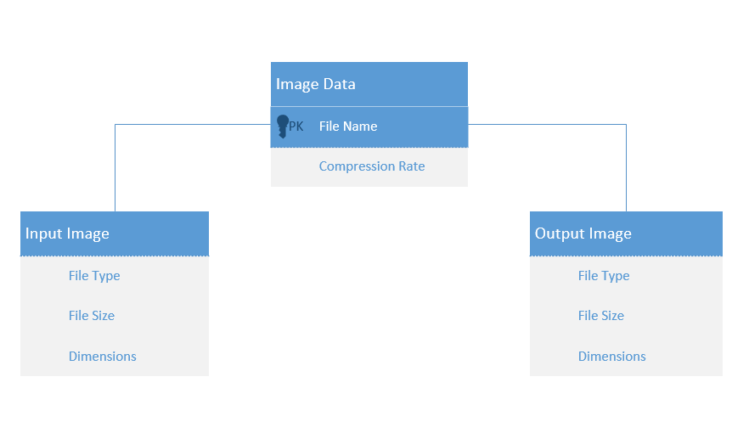

3.5 Design Constraints

User interface should be simple and straightforward.

